Purchase order Quote Delivery note

**bdc/quote/bdl number:Not completer ! Reserved for MBC-Solutions**

|  |  |
| --- | --- |
| Enterprise: NAME + LEGAL FORM | Contact:CONTACT PERSON |
| TVA: BE XXXX.XXX.XXX | Delivery date: CLICK HERE TO ENTER A DATE |
| Address: STREET + N°, POSTAL CODE, CITY, COUNTRY | Delivery address:STREET + N°, POSTAL CODE, CITY, COUNTRY |
| Telephone: PREFIX + NUMBER | Email: XXXX@XXXX.XXX |

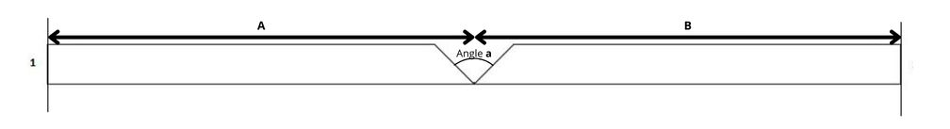

Number of plates: Indicate here the desired quantity

Length: 2800mm

Plate type: A

Rated cut: 1. ABA

2. ABA

Thickness: 12.5mm

Angle: **a**: 90°

|  |  |
| --- | --- |
| **A** | **B** |
| 300 **mm** | 300 **mm** |