Purchase order Quote Delivery note

|  |  |
| --- | --- |
| Enterprise: NAME + LEGAL FORM | Contact: CONTACT PERSON |
| VAT: BE XXXX.XXX.XXX | Delivery date: CLICK HERE TO ENTER A DATE |
| Address: STREET + N°, POSTAL CODE, CITY, COUNTRY | Delivery address: STREET + N°, POSTAL CODE, CITY, COUNTRY |
| Telephone: PREFIX + NUMBER | Email: XXXX@XXXX.XXX |

**bdc/quote/bdl number:Do not complete! Reserved for MBC-Solutions**

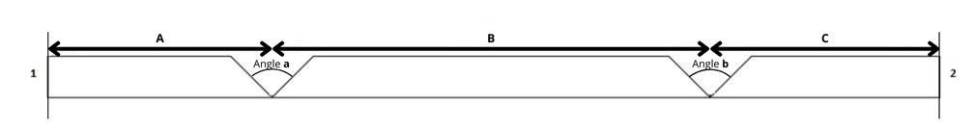

Number of plates:Indicate here the desired quantity

Length: 2800mm

Plate type: A

Thickness: 12 mm

Angle: **a**: 90°

**b**: 90°

Measurement: A: 250 mm

B: 100 mm

C: 250 mm